Ellie Chipps
Formal Lab Report B
CHEM 2081-004
11/30/2023

Introduction
The goal of this lab report is to use the various forms of spectra imaging provided to identify the unknown identity of the provided unknown compound. NMR, FTIR, and MS were used to identify the unknown. This skill is important and necessary as it is commonly used in fields such as pharmaceuticals and forensics.

Data:
NMR
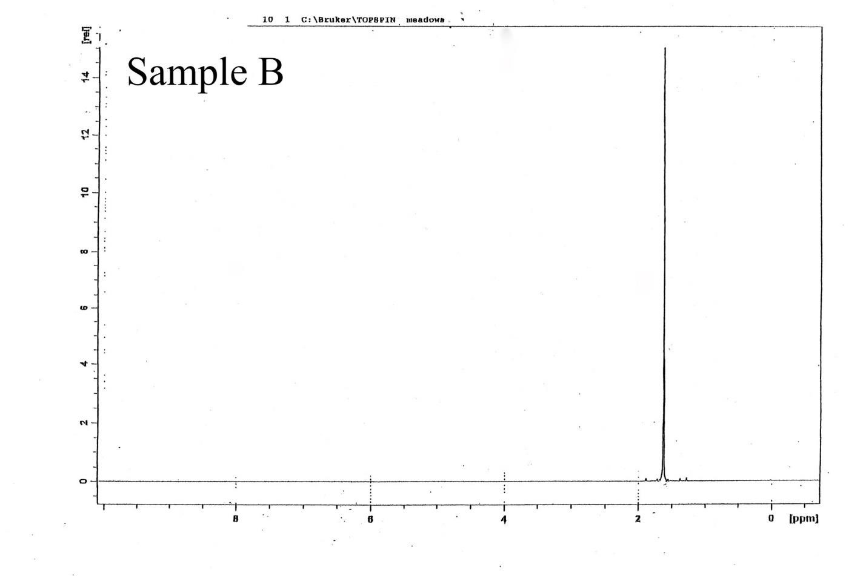

FTIR
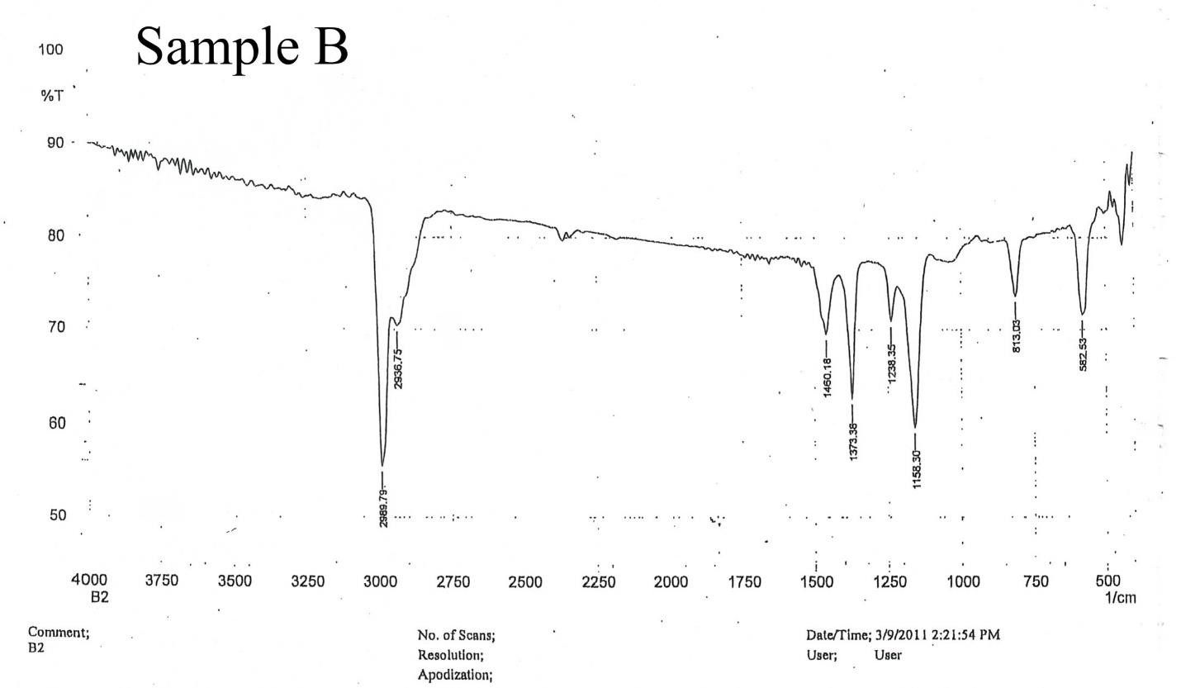
MS
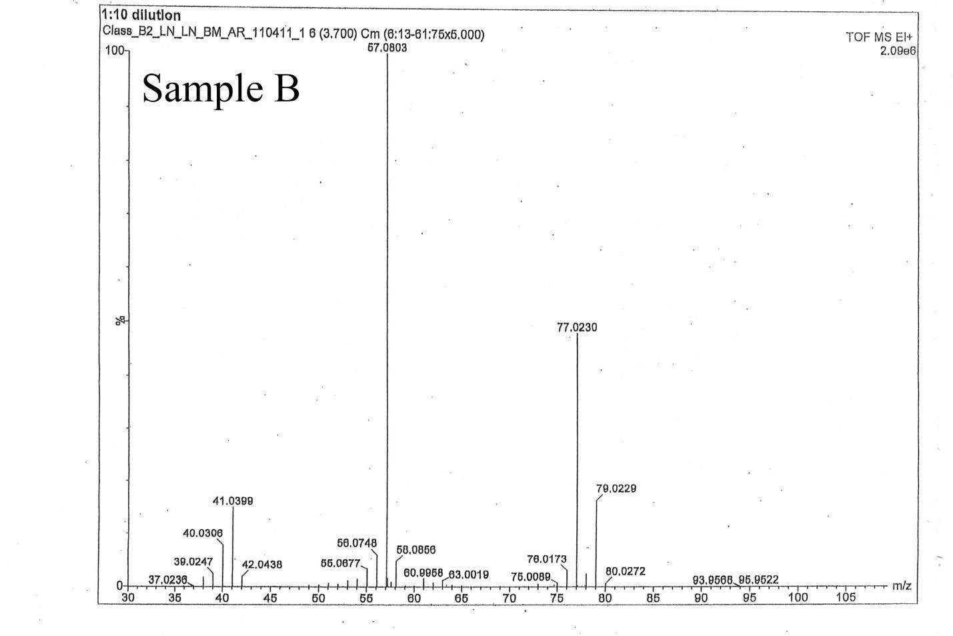
Results:
NMR, or Nuclear Magnetic Resonance, uses a broad pulse of electromagnetic radiation, exciting all the H and C nuclei simultaneously, causing a continuously decreasing oscillation by the decay of excited nuclei back to their stable energy distribution. In this NMR graph, there is a singlet peak which means all 18 protons are chemically equivalent to each other.
FTIR provides information on side chain groups. In an IR spectrum, energy plotted along the horizontal axis and the intensity of the of the absorption is plotted along the vertical axis. FTIR provides a rapid and effective method for identifying the presence or absence of simple functional groups. Anything below 1500 requires a computer to decipher. The two peaks around three thousand signify an alkane. Because of this we know there are no alkenes, alkynes, hydroxyls, or any other typical side chains.
Mass spectrometers function by ionizing the sample by electron impact and sorting the ions with a magnetic sector mass analyzer. Samples are first vaporized and then bombarded in the ion source by a stream of electrons with 70 electron volts (eV) of energy. The positive and negative ions are then separated based on attraction. In the graph above, the two largest peaks at 57 and 77. This means that the graph deals with radicals and makes sure that there is a uniform charge so that when it moves through the magnetic field there is not uniform movement. The two peaks in the graph are caused by this difference in mass. 77 is the mass of the overall compound, and 57 is where the radical knocks off one of the side groups and breaks the compound. 57 is m- 20 peak which is informative of whatever broke off had a molecular weight of around 20
Conclusions:
The results of the graph indicate that the compound is 2,2,2,3-tetramethylbutane.
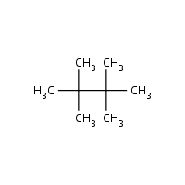
References:
Keller L, Joseph K, and Miguel S. 2023 Fall. CHEM 2081 Organic Chemistry 1 Lab Manual [lab manual]. Auburn (Al): Auburn University

